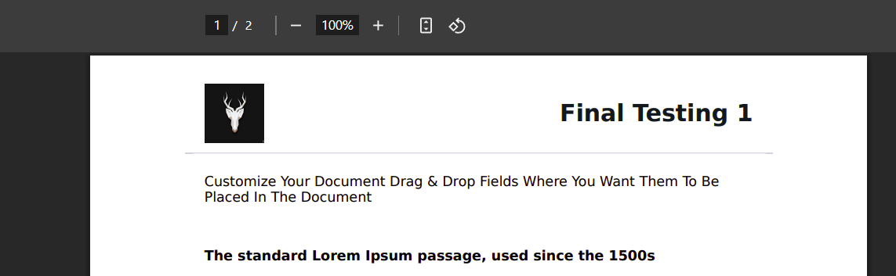  
  
36. Logo strech issue solved.  
  
  
  
  
  
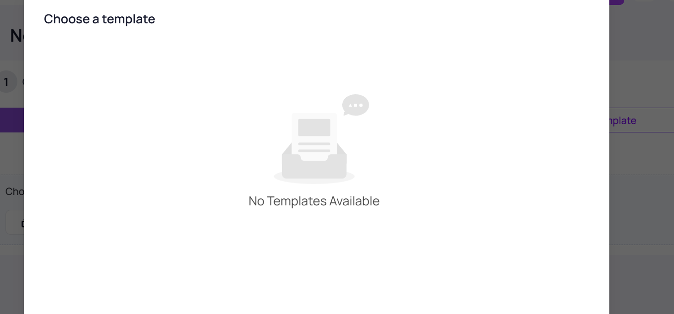  
  
40. If no template than message(no template).

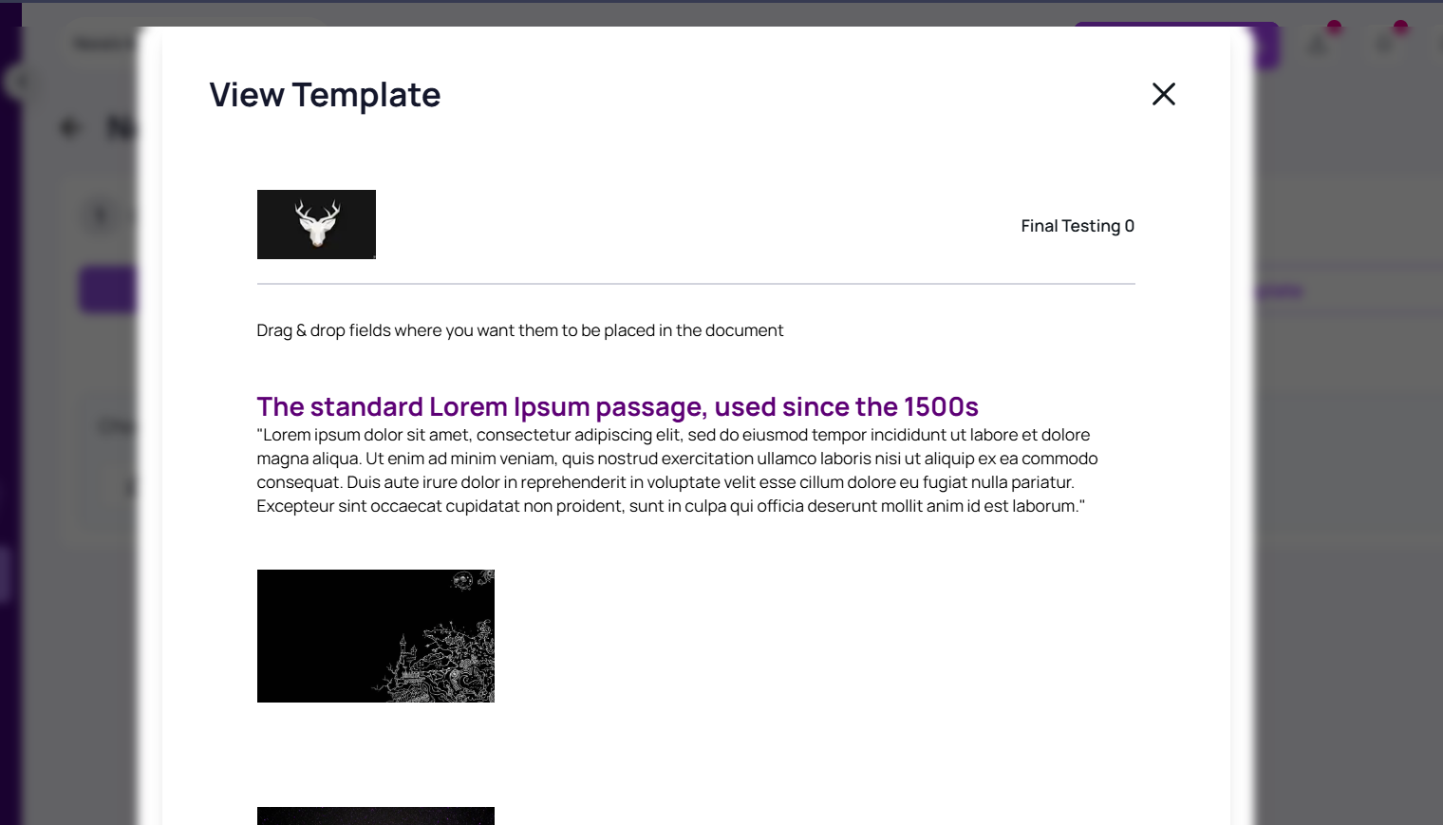  
  
39. Eye icon working.  
  
  
  
  
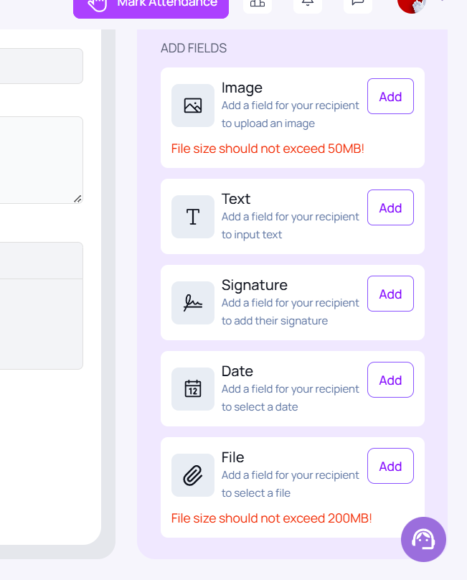  
  
41. Validation of image size and file size.