MongoDB Basic Queries Documentation

1. Introduction to MongoDB

MongoDB is a NoSQL database that stores data in JSON-like documents. It is known for its flexibility, scalability, and ease of use.

1. Setting Up MongoDB

To get started with MongoDB, you need to install it on your machine. Follow the official MongoDB installation guide for your operating system  
<https://www.mongodb.com/docs/manual/installation/>

1. Basic Queries
   * + - Creating a Database

To create a database in MongoDB, use the use command:



This command switches to myDatabase. If myDatabase doesn't

exist, MongoDB will create it when you insert the first document.

* + - * Inserting Documents

You can insert documents into a collection using the insertOne or

insertMany methods:

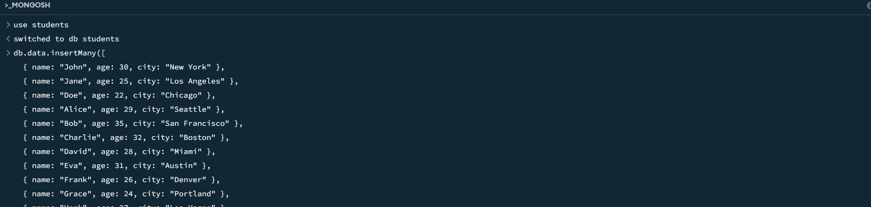

* Query Operators

Greater Than ($gt)

The $gt operator is used to find documents where a field’s value is

greater than the specified value.



Less Than ($lt)

The $lt operator is used to find documents where a field’s value is

less than the specified value.

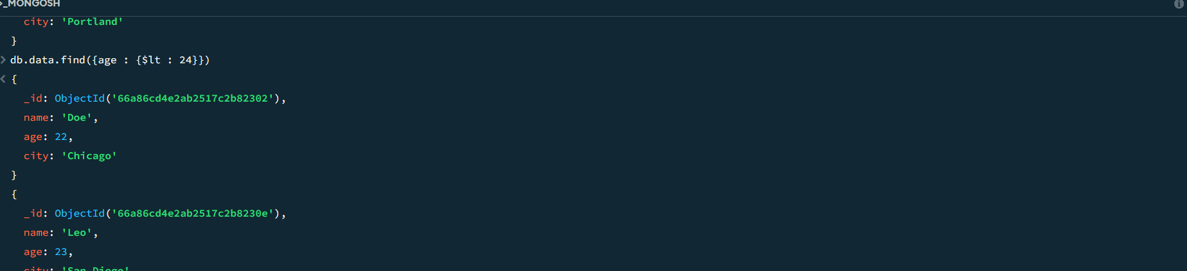

* Logical Operators

$and

The $and operator performs a logical And operation to join query

Clauses.

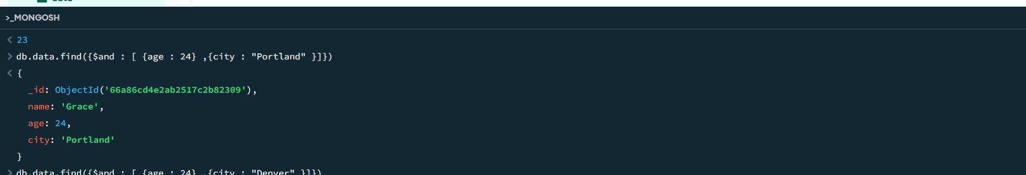

$or

The $or operator performs a logical OR operation to join query

Clauses.

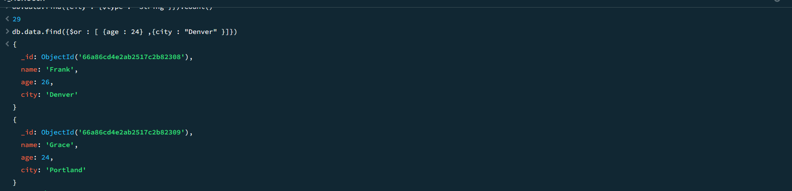

$not

The $not operator performs a logical NOT operation to join query

Clauses.

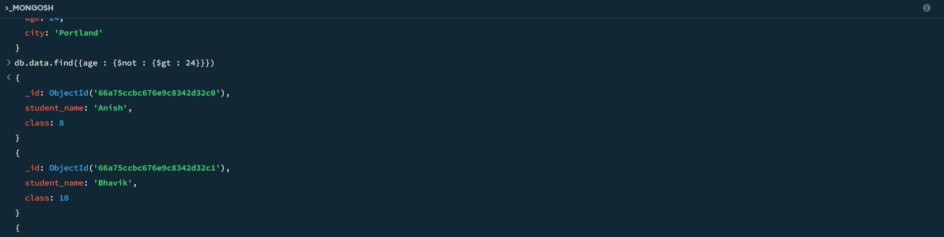

* Cursor Methods

Limit

The limit method restricts the number of documents returned by

a query. This is useful when you want to return only a subset of

documents

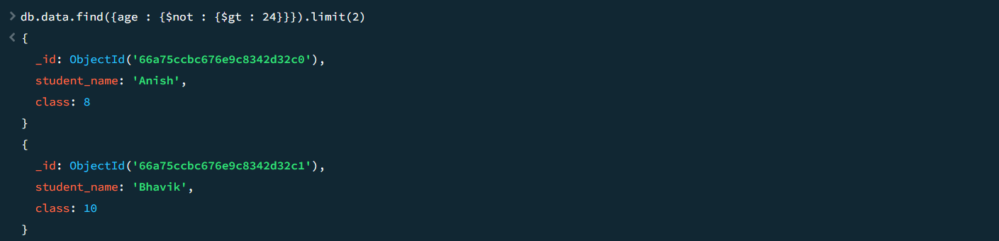

Sort

The sort method arranges the documents in a specified order. You can sort documents by one or more fields in ascending (1) or descending (-1) order.

Descending example

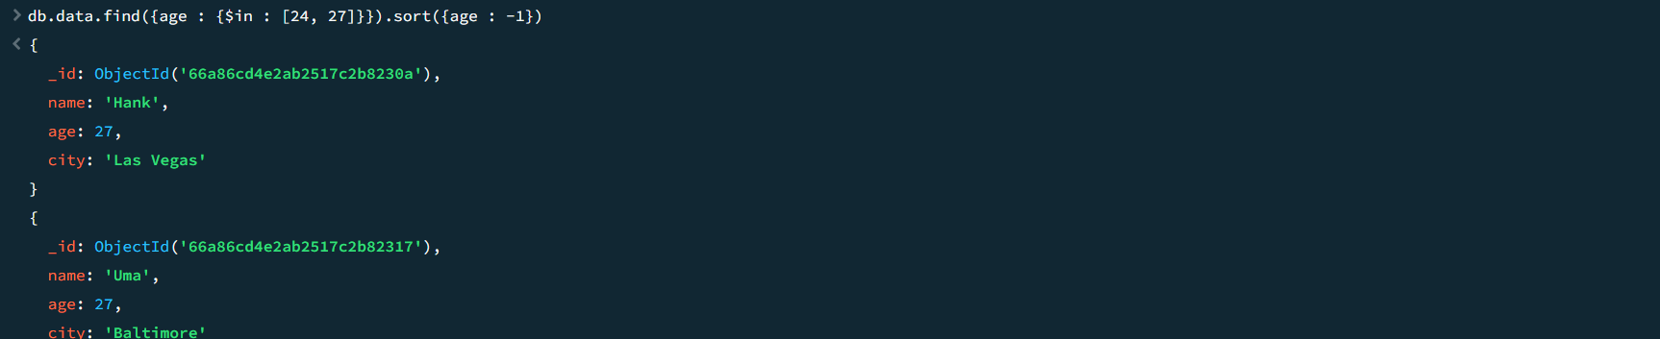

Ascending example

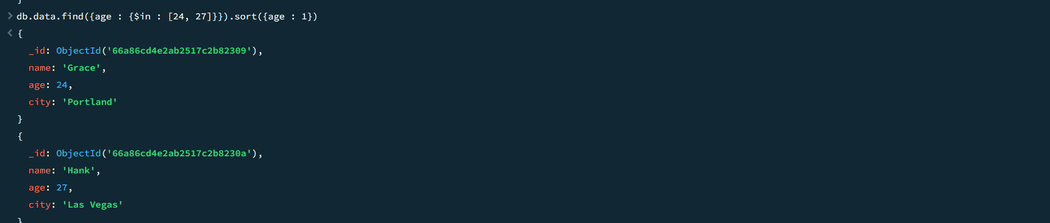

Skip

The skip method skips a specified number of documents in the result set. This is useful for pagination.

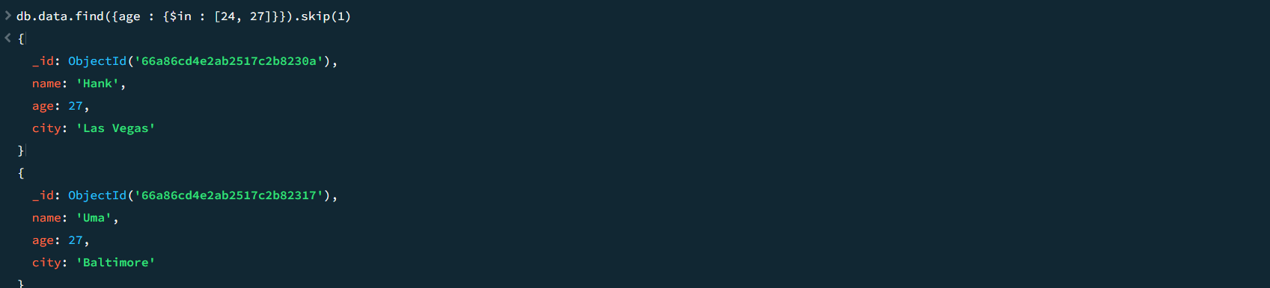

Count

The count method returns the number of documents that match the query criteria.



* Element Operators

$exists

The $exists operator checks for the existence of a field in a document.

db.myCollection.find({ age: { $exists: true } })

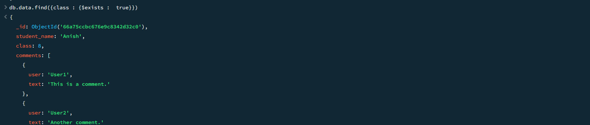

$type

The $type operator matches documents where the field is of a specified BSON type.

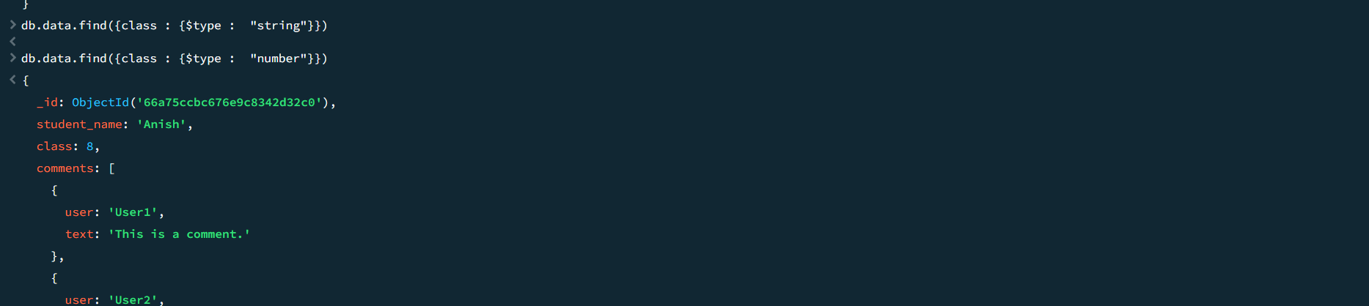

$size

The $size operator matches documents where the array field is of a specified size.

Example :-

db.myCollection.find({ comments: { $size: 2 } })

This query returns documents where the comments array has exactly 2 elements.

* Using Projections in Queries

To specify projections in a query, use the second parameter of the find method. The projection parameter is an object where you can include or exclude fields.

**Inclusion**

To include fields, set the field to 1. The _id field is included by default unless explicitly excluded.

db.collection.find(query, { field1: 1, field2: 1 })

