# ACR summary: Location filter in Find listing page

Author: ACR

Issues marked in red below

1. Click on the Location filter in the Find listing page open’s the Location filter popup correctly.
2. 💣Changed the Zip code area from Bellevue to Redmond in Location filter still displays the zip code of Bellevue.
3. Changed the Zip code from 98005 to 98011 displays the correct town in dropdown.
4. 💣The dropdown box that is listed below the Search box is not consistent with the length of the Search box.
5. Click the town in the dropdown changes the search value to newly selected town and the rest of the nearby towns remain unchecked while the selected town is checked.
6. 💣Click on Done button changes the pre-selected Category from Psychiatrist to Mental health counsellors and search results are fetched to the Zip code that is selected with wrong Category.
7. 💣Click on the Location filters retains the old Zip code in search value and the old town is unchecked and the old Category value retained.
8. Filter the Search radius (10 mi, 25 mi and 50 mi) filter’s the town according to the Radius selected.
9. Filter the Search radius (100 mi) filter’s results more town than Search radius (anywhere) has given.
10. 💣Uncheck the default town changes the Provider Category.
11. 💣Enter the invalid Zip code displays the correct text with hyperlink in the Search value. Clicking on the link takes the User to the Error form#3 with wrong UI.
12. Done button is enabled when town is unchecked in the form. It also disappears from the search listing page in the background.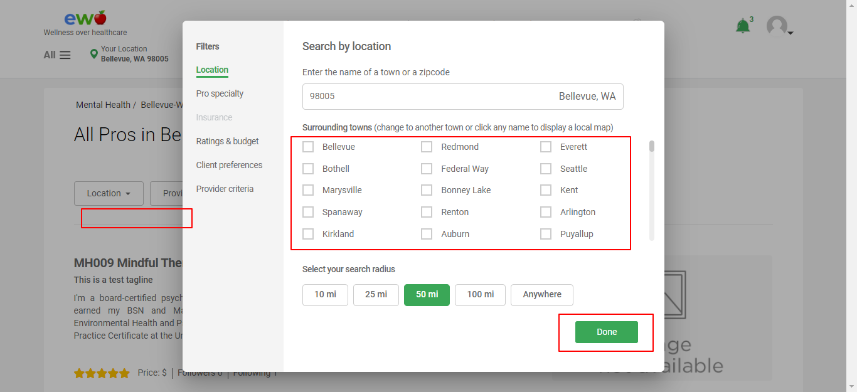

# Location search filter

## Changing search location

1. Changed default city from Kirkland to Bothell 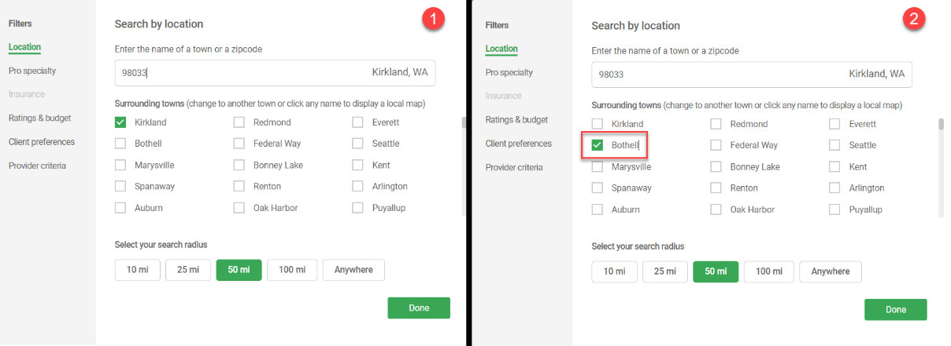
2. Selecting Bothell changes the display on the Search listing page (background screen)  
   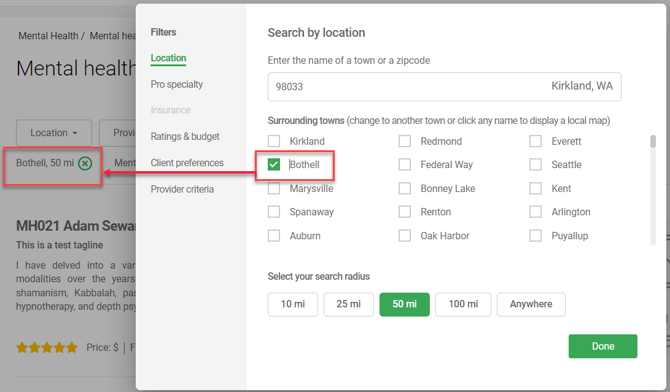
3. Selecting Done button displaysKirkland results again (below).
   1. Functional issue: Search listing with Location = Bothell is not shown.
      1. Need to check if there are any matching Pros in Bothell or not. None are displayed in the results.
      2. Even if there are none in Bothell, the search setting below Location button should display Bothell.
   2. Performance issue: When Done button is selected, system shows 7-10 seconds of grey screen before displaying results. Results are too slow for the small dbs we are currently handling. Expect further deterioration when we add more data.   
      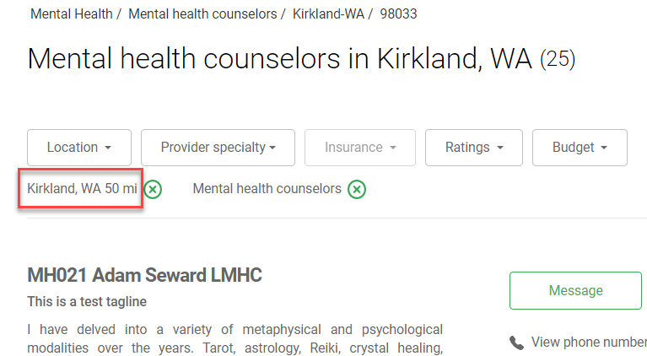
4. Clicking Location button again resets checkbox to Kirkland. Bothell is unchecked.  
   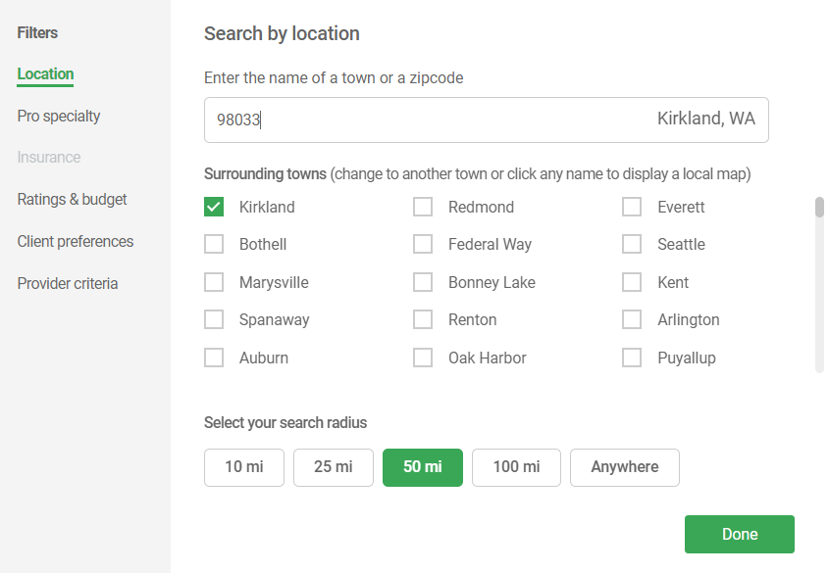
5. Consistency issue: System response varies from time to time
   1. When the Location button is selected:
      1. Sometimes, the Surrounding Town section takes a few seconds to populate the form.
      2. Sometimes, only the top search bar is displayed. The Surrounding town section below is not displayed…only white space is displayed.
   2. Selecting Spanaway checkbox in the above form:
      1. Only gave me grey screen
      2. Showed the Kirkland screen

# Provider specialty filter issues

## Click the Pro specialty filter

Default display below.

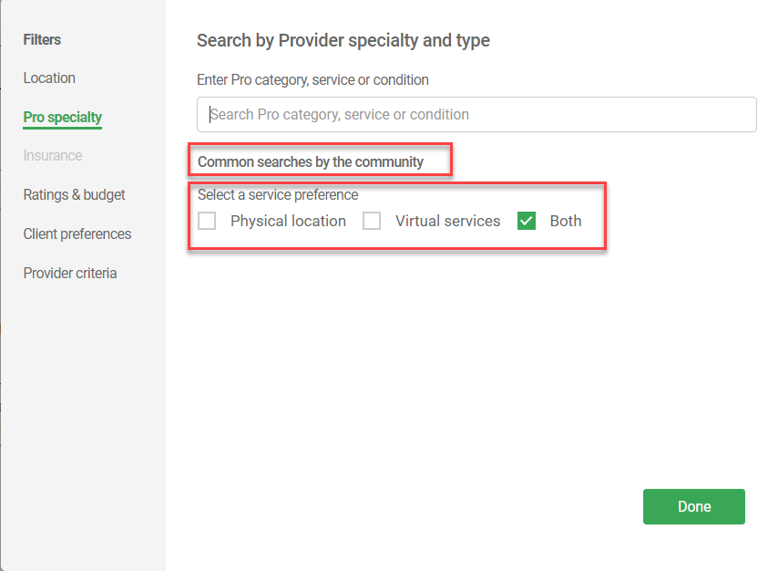

1. Common searches section: No data displayed.Form display is corrupted.
   1. This form should only be displayed with data for Common searches (the default view)
2. Service preference section is floating, must be anchored
3. Data entry makes no difference. Form is still corrupted  
   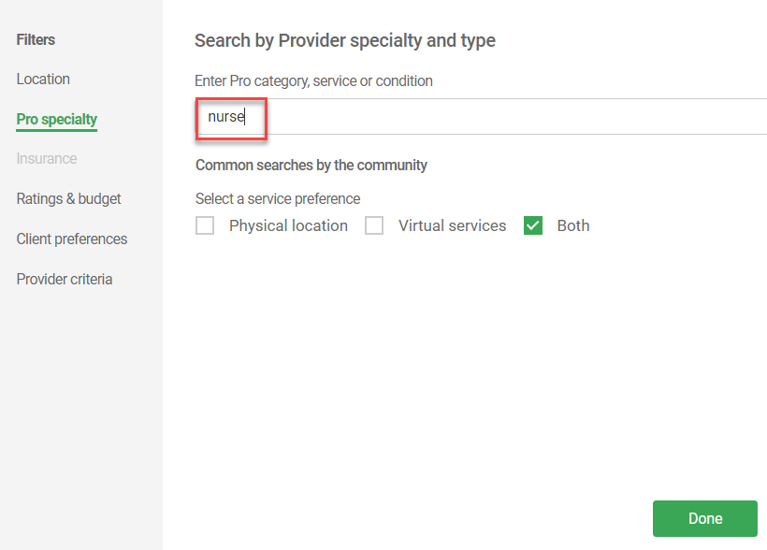
4. Clicking Done displays all Pros in system. This error must be blocked and correct behavior displayed.   
   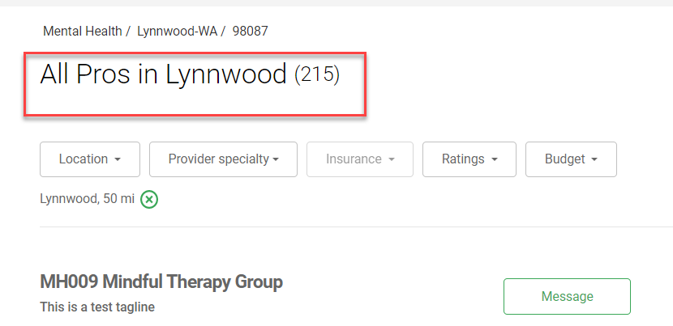
5. Location filter display is also corrupted  
   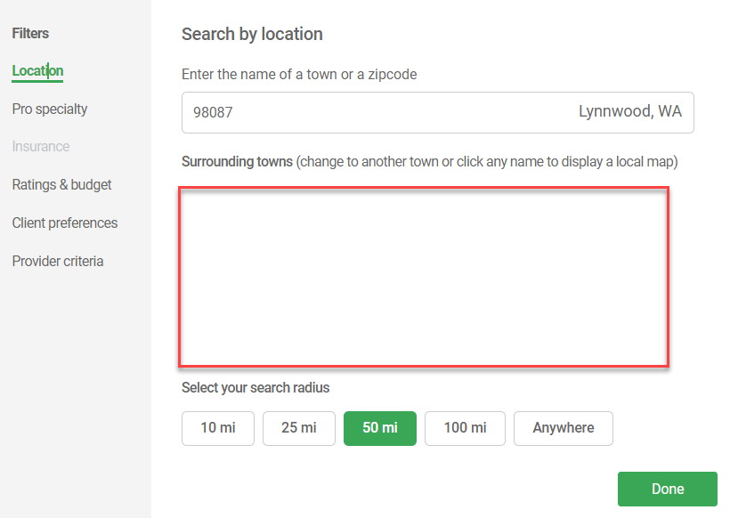
6. Browser tab Refresh shows a better display  
   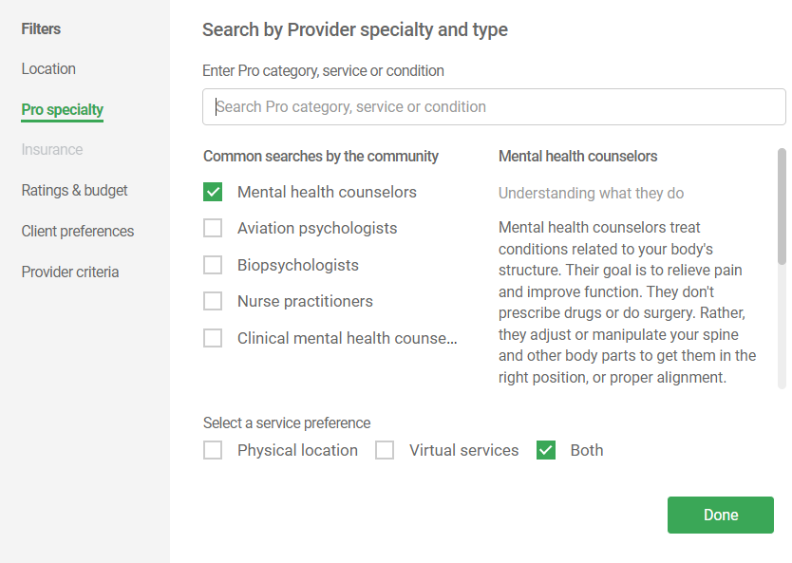

### Missing data issue

1. Selected Aviation psychologists and Done button  
   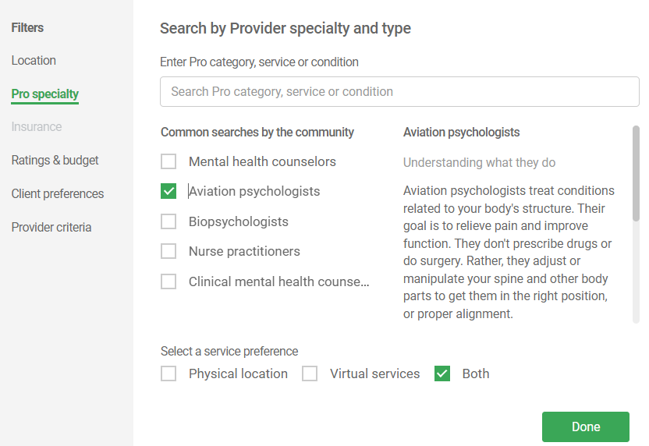
2. Issue: Pro categories with no supporting data are listed in the options above.
   1. Aviation psychologists data is not in the system.
   2. Biopsychologists data is not in the system(generated same error form below).
3. Issue: Error form design
   1. The error form below uses many very large fonts and needs Rework (Vivek)
   2. Figma was updated. All error forms must follow the same fonts, button and white spacing standards. Design system docs to be updated by Vivek.  
      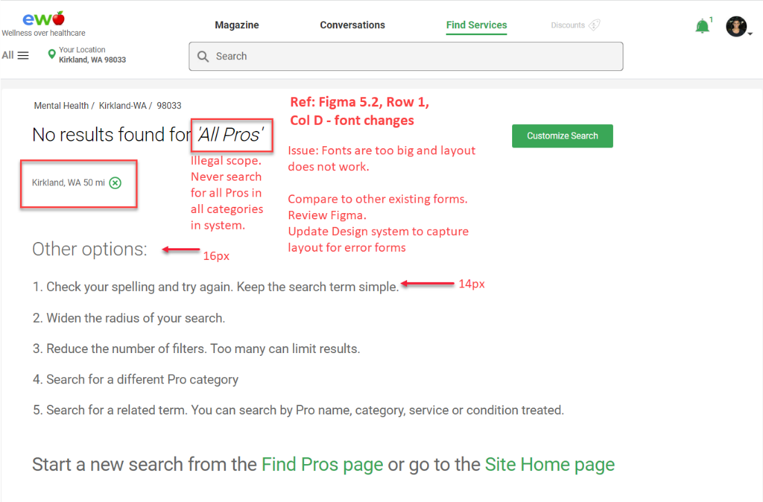
4. Selected Nurse practitioners’ and got results.
   1. Search listing is very slow, takes 4-8 seconds to be displayed. Can we prepare these listings in advance so that we don’t have to run a dbs query for every search?
5. Selected ‘Provider specialty’ filter – again got no data in the form  
   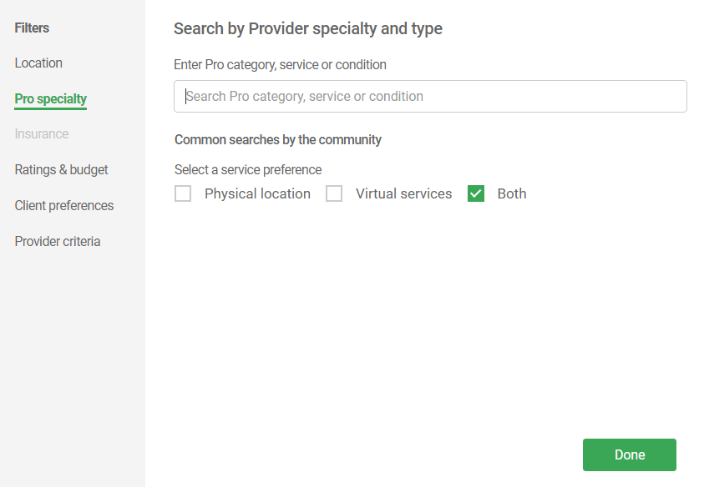
6. Clicking Done is the only way out of this form. Selecting it does not change the search listing.

# Pro Specialty filter Issues from ACR:

1. Performance issue: Predictive search in Pro specialty filter takes around 3-4 secs to load the results.
2. Performance issue: Click on Done button in Pro Specialty filter, search listing page loads in a delay of 10 seconds.
3. Opening Pro Specialty filter always shows results from trending search. Previously selected category/sub-category value is not retained. Anand to confirm this. 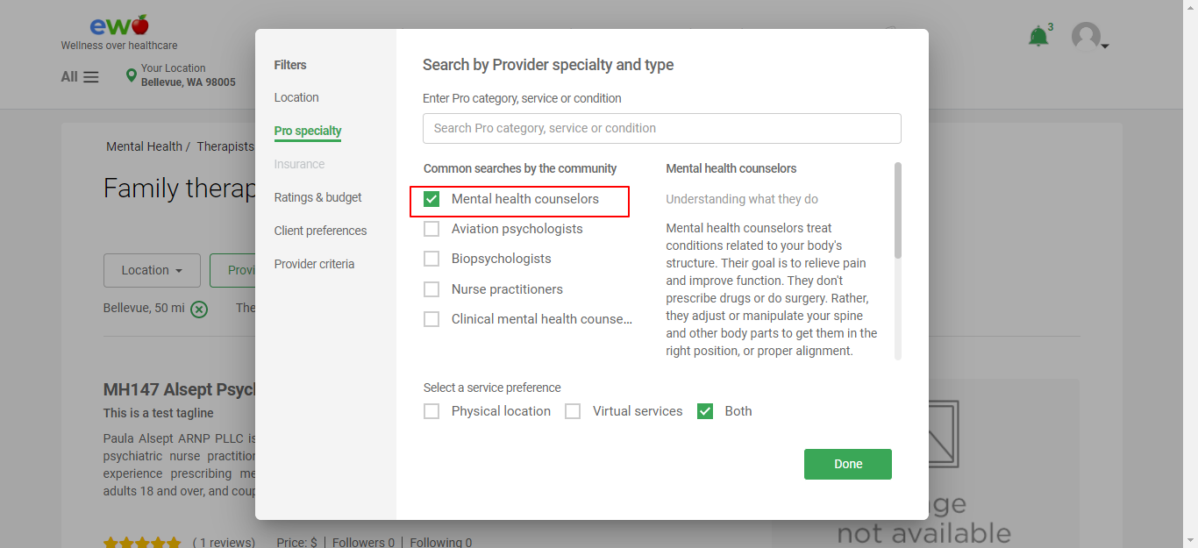
4. Click on Provider speciality filter and no value is checked in the form but the description is displayed for the search term that is selected previously. 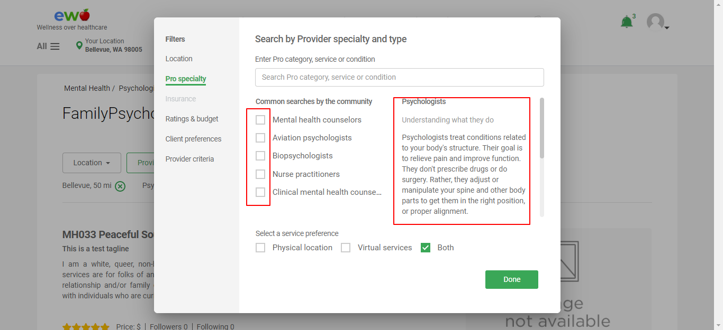
5. Select a Service preference checkbox and click on Done. Results are fetched for All pro. 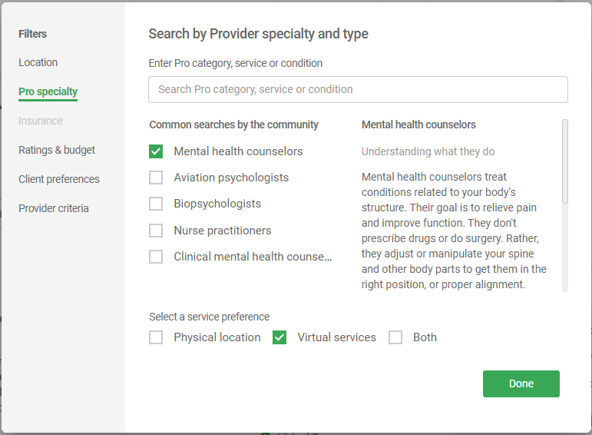 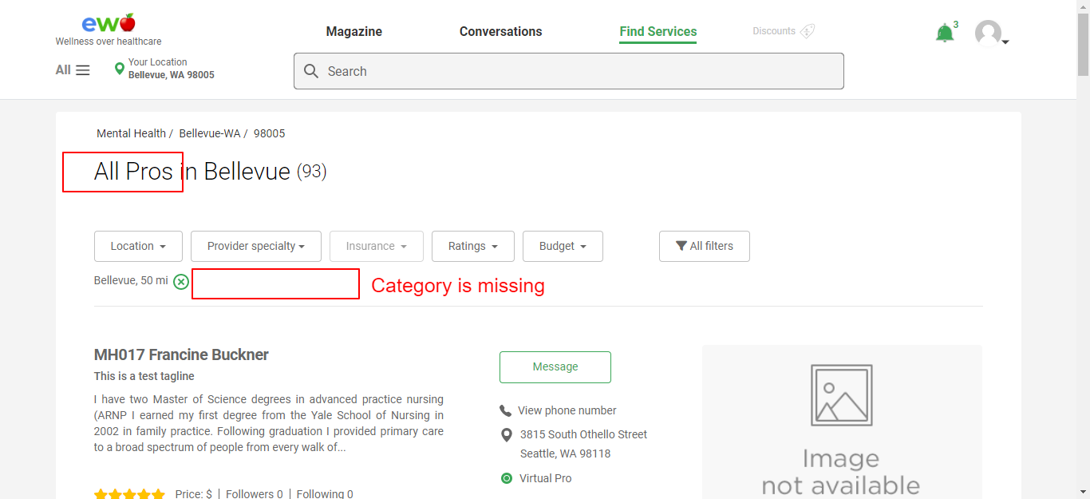
6. Search for the value that is already been checked and select the value from the dropdown. This unchecks the value that was previously selected. 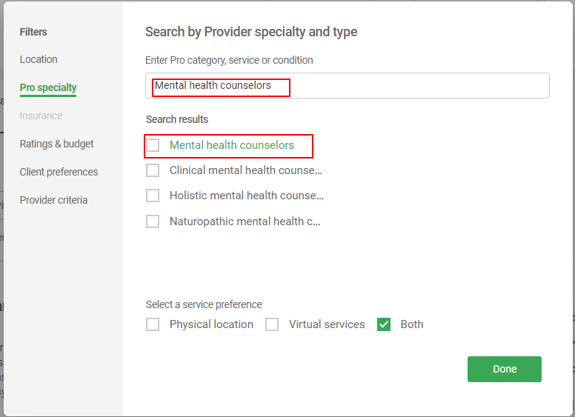
7. If no category/sub-category is selected and clicked on Done button, All pro from the system are listed in search listing. 